

**School of Engineering and Computing**

**MSc <*insert programme title here*>**

**Interim Report**

**Agile Methodology and Its Impact on IT Project Success: A Case Study of Unilever**

**by**

***<student’s full name>***

***<student’s banner id>***

**Date of submission: *<dd/mm/yyyy>***

**Supervisor: *<full name of supervisor>***

**Moderator: *<full name of moderator>***

**Table of Contents:**

**1. Introduction:** 3

**1.1 Problem Statement:** 3

**1.2 Main Aim:** 4

**1.3 Objectives:** 4

**1.4 Research Questions:** 5

**1.5 Significance of the Research:** 5

**2. Summary Literature Review:** 6

**2.1. Agile Methodologies and Their Principles:** 6

**2.2. Comparative Studies on Agile and Traditional Project Management:** 7

**2.3. Success Factors for Agile in Large Organizations:** 7

**2.4. Agile in Large-Scale Organizations** 8

**2.5. Hybrid Approaches: Blending Agile and Traditional Methods:** 8

**3. Research Methodology:** 9

**3.2 Case Study Design:** 9

**3.1 Dataset Description:** 10

**3.3 Data Collection:** 10

**3.4 Data Analysis:** 11

**3.5 Data Presentation:** 15

**4. Current Progress:** 16

**5. Plan for Completion:** 16

**6. Potential Challenges and Mitigation Strategies:** 17

**7. Conclusion:** 17

**8. References:** 18

**LIST OF FIGURES:**

Figure 1: Dataset Overview 11

Figure 2: General data information. 11

Figure 3: Visualize missing data as a heatmap 12

Figure 4: Visualize distribution of Agile and non-Agile methodologies 13

Figure 5: Bar plot of satisfaction with development method 14

Figure 6: Hypothesis Testing 14

Figure 7: Frequency distribution of the satisfaction with Agile vs non-Agile 15

# **1. Introduction:**

The agile methodology has become very popular in software development within the last two decades here it provides flexibility, these are iterative, and are customer-centered. While Waterfall PM is rigid with strict plans and phases to be followed, Agile methodology is an interconnected group process where people are designed to deliver a potentially usable and valuable solution to the customer as soon as possible. The essence of Agile as put in the Agile Manifesto (Beck et al., 2001), has been embraced across several business sectors especially those whose projects involve Information Technology, location where requirements may be inherently volatile. The purpose of this project therefore will involve assessing the role that Agile methodologies play in determining the success of IT projects case of Unilever. This will involve a comparison between the Agile development methods and other non-Agile approaches to project management by evaluating project success indicators including time, cost, risks, and level of customer satisfaction.

It is for this reason that evaluating the applicability of Agile methodologies, the use of a global company such as Unilever that has a firm IT structure in its provision of a wide range of products and services is most suitable (Qumer & Henderson, 2008). Using the IT projects in Unilever as a case, this research seeks to determine if Agile methodologies enhance project performance over the traditional approach to offer insights on the viability and success enablers of large firms.

This interim report will describe the work accomplished to date and will include a brief literature survey of the available literature, a description of the research method used in the project, and a work plan for the completion of the project. It will also identify possible limitations and countermeasures to the investigations to keep the study on the right track for the successful accomplishment of the project.

## **1.1 Problem Statement:**

The ever more intricate and rapidly changing nature of IT projects is manifested in challenges that can threaten AMAs, as well as other organizations, abilities to deliver projects on time, within budget, and according to customer requirements. Many of the former approaches to project management do not consider the flexibility of the process and require an enormous number of investments in detailed planning. This has resulted in time wastage, costly expenses, and inefficient achievement of goals which reduce the efficiency of IT projects. There are now problems with more traditional methodologies for project management, like rigidity, linear progress, and the lack of end-user involvement; and agile approaches, that involve more adaption, cyclical development, and customer participation, might be the answer to these. However, there is still a scholarly call for quantitative data to evaluate the real effects of Agile practices on IT project success, in this case in large organizations such as Unilever where Agile and non-Agile are used on some projects (Rao et al., 2011). This study will seek to fill this knowledge gap on how Agile methodologies fair against conventional practices regarding the most important metrics like schedule, cost, quality, and customer satisfaction.

## **1.2 Main Aim:**

This research is set out with the aim of assessing the effectiveness of Agile methodologies on the success of IT projects in Unilever. This paper will present a quantitative analysis of data compiled for Agile and non-agile projects to determine if Applied Agile leads to increased project performance when it comes to time, cost, risk, and customer satisfaction. The results will have implications for the application of Agile methodologies in large corporations and suggestions for future practices of project management.

## **1.3 Objectives:**

To achieve the aim of this research, the following specific objectives will be pursued:

* To conduct a comprehensive literature review on Agile and non-Agile methodologies, focusing on their application in IT project management.
* To gather empirical data from IT projects at Unilever, both Agile and non-Agile, using key performance indicators such as project completion time, budget adherence, risk mitigation, and customer satisfaction.
* To analyze and compare the performance of Agile and non-Agile projects at Unilever, identifying patterns, strengths, and weaknesses in both approaches.
* To evaluate the factors influencing the success or failure of Agile methodologies in IT project management.
* To provide recommendations for optimizing project management strategies at Unilever, based on the findings of this research.

## **1.4 Research Questions:**

1. How do Agile methodologies impact key performance indicators such as project timelines, budget adherence, and customer satisfaction in IT projects at Unilever?
2. What are the success factors and challenges in implementing Agile methodologies within large organizations like Unilever, compared to traditional project management approaches?
3. How does the use of Agile methodologies influence risk management and adaptability in IT projects, particularly in the context of rapidly changing project requirements?

## **1.5 Significance of the Research:**

In this study, several factors make the research important. First of all, it responds to a major gap in knowledge in the IT sector referring to the actual effects that Agile processes have especially in a large-scale organization such as Unilever. Agile practices are recognized to provide greater flexibility and responsiveness in project environments today, yet few studies have compared the effectiveness of the different Agile practices (Mostafa, 2015). This research will help to address that issue by presenting an extensive comparison of Agile and non-Agile project results.

Second, the implications of this research will be of importance to IT project managers and organizations that want to adopt, improve, or select optimal project management frameworks. This study will assist organizations in making better decisions in the adoption and effective implementation of Agile methodologies due to the identification of conditions that lead to success or failure. In addition, the results could be used by Unilever to optimize its project management practices and increase project efficiency as well as customer satisfaction.

Last but not least, this research contributes to the global portfolio of work undertaken in the project management methodologies field by providing empirical information on the efficacy of Agile approaches in complex, massive-scale organizational contexts. It contains the possibility of having an impact on future studies and will stimulate additional discussion on the topic of hybrid Agile models that integrate the elements of conventional approaches.

# **2. Summary Literature Review:**

The agile approach has its origin in the Agile Manifesto developed by Beck et al in the year 2001; this document set more value on the effective collaboration of individuals and communication rather than the procedures and tools, delivering working software more than creating documentation, customer collaboration more than carrying out contracts and responding to change more than following a plan. Such principles are in contrast with the Waterfall approach, within which the process is linear and divided into stages – from requirements gathering to design, development, testing, and deployment (Adenowo & Adenowo, 2013). Advocates of Agile claim that investments in the approach help to minimize the impact of the risks and provide for more flexibility when it comes to constantly changing customer requirements which is highly likely in software development projects.

## **2.1. Agile Methodologies and Their Principles:**

Agile frameworks comprise several frameworks with Scrum, Kanban, Extreme programming (XP), and Lean software development among others. Each of these frameworks has its own set of practices, but they all adhere to the core principles of Agile: reiteration, interdisciplinary cooperation, and feedback loops and improvement. Sprint and put, Scrum's inventors, Schwaber and Sutherland (2020), define it as a process for creating, building, and continuously improving products or services through successive cycles of work. One of the advantages coming from the usage of Scrum is the ability to change something constantly – this is possible due to the cyclic structure of Scrum and is used to respond to emerging new requirements without directly affecting the overall scheme of the project.

The other mainstream Agile framework is Kanban which is aimed at visualizing the work, controlling the amount of work being performed as well as maintaining the work's flow (Anderson, 2010). Kanban's boards allow teams to track how they are progressing through their workflow at any time and recognize problem areas. Based on the outlines of Poppendieck and Poppendieck (2003), lean software development is a modification of lean production disguised as lean software improvement.

## **2.2. Comparative Studies on Agile and Traditional Project Management:**

A few samples of comparative research work present how Agile has advantages over other conventional project management techniques. Serrador and Pinto (2015) surveyed over 1000 projects to conclude that Agile was more successful than the Waterfall method. Based on their studies, they argue that Agile addresses program and organizational priorities of customer collaboration and flexibility and thus yields greater success. Likewise, Kupiainen et al. (2015) also provided a systematic literature review and found out that Agile measures such as the velocity of the team and burndown chart facilitate better tracking and improved identification and handling of problems and so on, therefore, Agile metrics make the team more efficient and enhances the success rates among Agile projects.

However, not all works presented tend to endorse Agile without a second glance. Conboy (2009) also points out that the Agile method can be very useful for small to medium development projects but could not be applied to very large and very complex development projects where there is a great need for documentation and formal procedures. Similarly, Boehm and Turner (2004) explain that since Agile is fully flexible, costs and requirements are likely to grow as well as the requirements definition is not likely to be complete, which leads to project delay and cost increase. These critics' claims state that a more manufacturing-oriented methodology such as Waterfall with the right focus on initial planning and rigid workflow may be more appropriate when a specific contract length and deliverables are required due to fewer possibilities of scope slippage.

## **2.3. Success Factors for Agile in Large Organizations:**

Academic sources also recommend that cultural change, support from leadership, and teams' willingness were the key factors, that defined Agile success in organizations like Unilever. Campanelli and Parreiras (2015) note that Agile methods must be adjusted to the organization’s needs of a particular company. They postulate that the industrial-wide implementation of Agile has become a recipe for disaster in most large organizations with intricate projects. As such, it is more strategic for organizations to identify and apply Agile practices suited to the organizations and corporate objectives, system limitations, and personnel. As a result, 'Agile' methodologies will focus on learning how Unilever has implemented these frameworks given the fact that the organization is a company with a wide and global IT project portfolio.

## **2.4. Agile in Large-Scale Organizations**

Large-scale organizations are increasingly demonstrating interest in the implementation of Agile methodologies. Although Agile was originally intended for, and aptly applied to, small, collocated teams in fast-changing requirements, its adoption and applications have increased in large enterprises such as Unilever. Scaling up does bring with it unique challenges and complexities. According to Dikert et al., large-scale Agile transformations require adaptation of their classic Agile frameworks for complexities introduced by large teams and organizational hierarchies and extensive involvement of stakeholders. Key challenges identified in the systematic literature review on Agile transformations in large organizations include resistance to change, lack of management support, and difficulties related to the maintenance of coordination across teams. They also indicated that organizations should fit Agile practices into their contexts, which could be in hybrid model forms and integrate traditional project management methods into Agile.

Moe et al. (2010) further identify leadership and team autonomy as paramount variables that ensure Agile works within large organizations. In instances where decision-making remains highly centralized, self-managing agile teams face challenges in flexibility and speed. This calls for Agile transformations to change the organizational culture by allowing the organization to be more decentralized in terms of decision-making and empowerment of teams. Unilever is among the large-scale multinational corporations that offer ideal settings for examining how Agile has been adapted and scaled up to fit large and diverse projects. The given study will discuss how Unilever overcomes these problems and what adaptations have been made to ensure Agile methodologies work across its global IT operations effectively.

## **2.5. Hybrid Approaches: Blending Agile and Traditional Methods:**

Considering that the need for project management has always been evolutionary, hybrid project management approaches are one of the common current approaches adopted where organizations are faced with the diverse needs of projects. These hybrid models will allow organizations to exploit the flexibility of Agile in areas that call for rapid adaptation and customer feedback while retaining structured planning and documentation processes from traditional methods for other aspects of the project. One of the first to advance a balanced approach from Agile to traditional methods was Boehm and Turner. They say Agile is ideal for environments where requirements are volatile or change at a rapid pace, but traditional methodologies would be more suitable for projects that require upfront planning, regulatory compliance, or extensive documentation. Such a hybrid approach enables an organization to switch from one methodology to the other. This can be depending upon the needs of different phases of various projects.

In large organizations, like Unilever, where projects can span across different departments, technologies, and geographic locations, hybrid approaches may be required to meet the variety of complexity. Such a project may follow Agile practices for the software development and customer-facing components but adhere to a more traditional Waterfall approach in the infrastructure and compliance-related aspects. Other studies by Stettina and Hörz (2015) reveal that in cases where Agile cannot be applied, for instance, in very regulated environments, projects with fixed deadlines, or fixed-price contracts, hybrid models turn out to be more efficient. A study they conducted on Agile adoption in large-scale organizations showed that hybrid models were able to adapt to the continuously changing needs of customers without losing control and predictability, which such a highly structured environment requires.

This study will find out, Unilever, whether the company has adopted hybrid approaches to executing its IT projects and to what extent these models impact overall project success. Precisely, this research intends to assess how well Unilever balances the adaptability of Agile to the formalized process in managing and executing its projects and, in turn, has ensured improved performance of various types of IT projects.

# **3. Research Methodology:**

The study approach for this work is the quantitative research strategy, specifically a case study based on Unilever’s IT projects. The research method, therefore, seeks to describe the level of success of IT projects when implemented through the use of Agile methodology with views to comparing it with those IT projects that have not been implemented via Agile (Bloomfield & Fisher, 2019).

## **3.2 Case Study Design:**

The research design is a concurrent case study that seeks to compare the IT projects at Unilever that have been undertaken with the use of Agile methodologies to those that have been undertaken using conventional methodologies (Islam & Ferworn, 2020). The emphasis is given to the identification of primary insights concerning Agile and non-Agile strategies with the help of the quantitative data collected from the Kaggle dataset. This research work aims to use a cross-sectional method to analyze the correlation of Agile practices with factors such as time, cost, risk, as well as customer satisfaction. This means that besides the dataset, some other project reports will be reviewed from Unilever if available to check the generalizability of the findings to large-scale corporate environments.

## **3.1 Dataset Description:**

The "Software Development Methods" dataset available on Kaggle contains survey results of the software development methods from different professionals. It retains information like the number of years the company has been in existence, and the position of the respondent besides Preferred and practiced software development methodologies including the Agile and non-Agile like Scrum, XP, DSDM, and FDD. The survey also questions respondents about the rationale for adopting specific methods, their interest in transitioning to Agile, and their level of experience with Agile. Communication preferences, project management approaches as well as the general satisfaction levels of their developmental process were also explored. This population sample can be useful to investigate current industry practices and serve as the main input for the subsequent comprehensive research of the relationship between Agile methodologies and the success of IT projects.

## **3.3 Data Collection:**

This paper focuses on survey data extracted from the Software Development Methods dataset obtained from the Kaggle website. The dataset comprises a rich set of variables highlighting potential antecedents of software development methodology choice, such as team size, project type, and industry. Furthermore, project data unique to Unilever (if available) will also be analyzed in addition to the Kaggle dataset to make sure that research results are relevant to the setting of large multinational firms like Unilever. Data collection focuses on key performance metrics, including project timelines, cost efficiency, risk management outcomes, and client satisfaction levels.

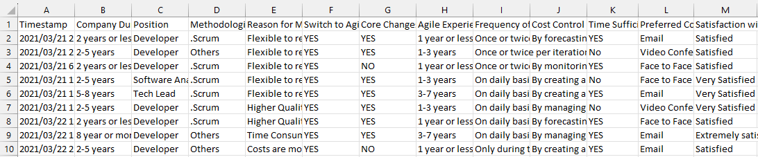

Figure 1: Dataset Overview

## **3.4 Data Analysis:**

Analytical regression and hypothesis tests will form the basis of quantitative analysis in this research (Costa, 2017). The purpose is to analyze the qualitative characteristics that define success in terms of time, cost, and customers, with Agile and non-Agile projects. Frequency distribution will be used to present the results while hypothesis testing will be used to test the significance of differences between Agile and traditional projects. Quantitative data materials will be collected and analyzed through applications such as Python programming with the emphasis made on the visualization of the trends suggesting positive impacts of Agile methodologies on business (Ivezić et al., 2020).

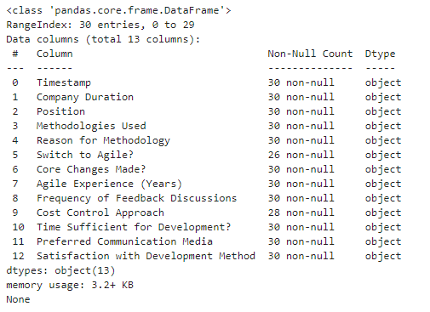

Figure 2: General data information.

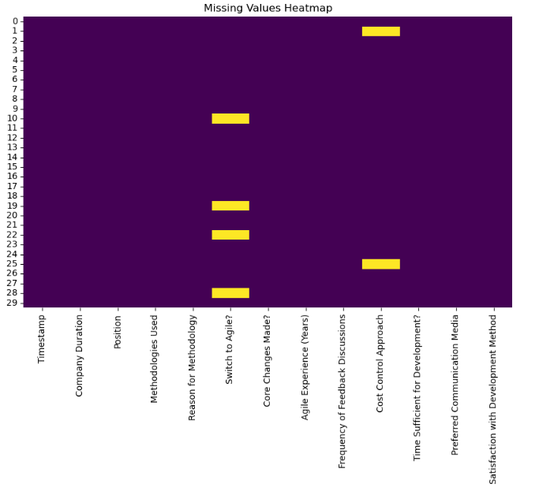

Figure 3: Visualize missing data as a heatmap

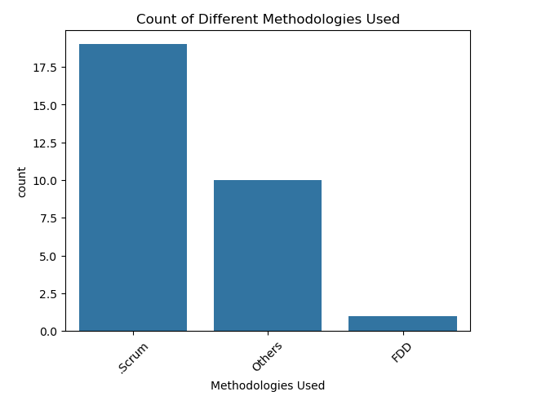

Figure 4: Visualize distribution of Agile and non-Agile methodologies

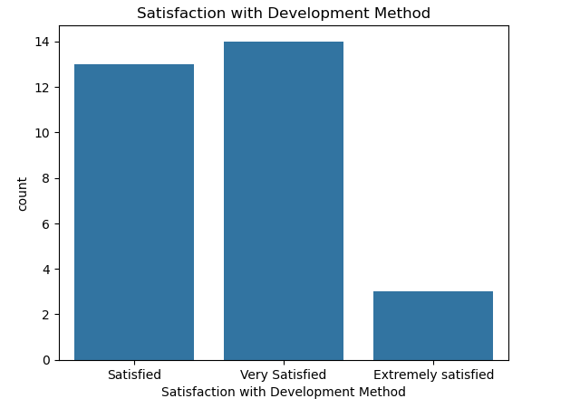

Figure 5: Bar plot of satisfaction with development method

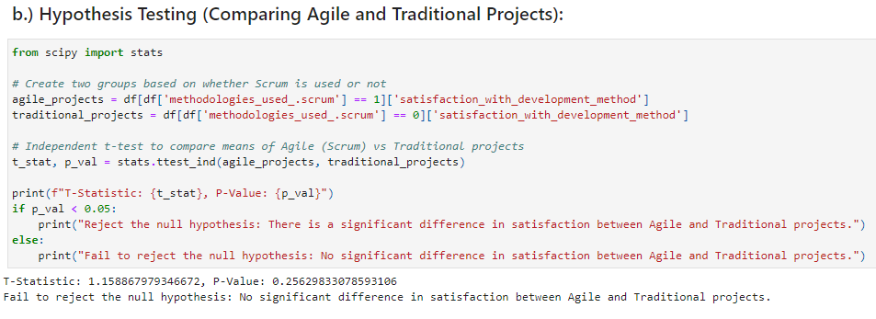

Figure 6: Hypothesis Testing

**********

## **3.5 Data Presentation:**

All results of the data analysis will be presented in the form of tables, graphs, and charts. Comparative Graphs of change in KPIs moving from traditional methodologies to Agile are to be developed (Brad et al., 2016). These visuals will ease the process of making conclusions concerning the efficiency of Agile within the projects of IT Unilever since such presentations will give a clear picture of the level of improvement brought by the implementation of Agile. Further, to augment the data presented in the tables, a narrative summary of key findings will be included provision of key observations from the study.

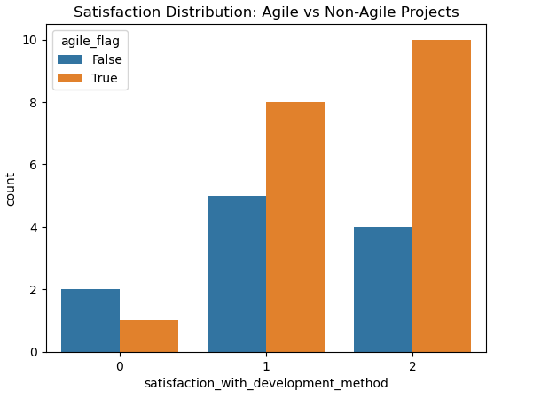

Figure 7: Frequency distribution of the satisfaction with Agile vs non-Agile

# **4. Current Progress:**

In the previous section, the literature review section has been implemented as regards Agile methodologies and IT project management. Comparative research on the use of Agile and traditional project management models has been systematically completed, as well as investigation of issues that affect the effectiveness of Agile in large enterprises. Data has been collected and initial data preprocessing and analysis have been completed. Some of the recalculated initial trends of Agile projects indicate that these projects set the timeliness equal to or less than the speed of Agile implementation and ensure higher levels of customer satisfaction, however, subsequent research is needed for generalization of such effects.

# **5. Plan for Completion:**

The following outlines the remaining steps for completing this project, to visually track the progress of tasks:

* **The interim report should show us your progress half way through the project – you need to clarify what work you have performed, describe the data, include samples in appendix, show pre and post cleaned data, give reasoning for actions, explain the data’s meanings, it’s purpose, etc. provide explanations for actions, and provide clear explanations of graph results – why that type of graph was chosen etc.. more detail on your work - the what/why/how etc.**
* **Show code samples in appendix, describe reasoning/functions etc**
* **October 2024**:
  + Finalize data analysis, focusing on key performance indicators such as project timelines, cost management, and customer satisfaction for Agile and non-Agile projects.
  + **Status**: Completed
* **November 2024**:
  + Complete the drafting of findings, including detailed data interpretation and visualization.
  + **Status**: In Progress
* **December 2024**:
  + Review and refine the analysis, incorporating feedback from the supervisor.
  + Begin drafting the final report.
  + **Status**: Not Started
* **January 2025**:
  + Submit the final report, ensuring that all conclusions are backed by data and the research objectives have been fully addressed.
  + **Status**: Not Started

# **6. Potential Challenges and Mitigation Strategies:**

One of its limitations is whether all the responses of the Kaggle dataset which captures responses from different industries appropriately capture the context of Unilever's IT project environment. To address this, where possible, the Kaggle dataset will be complemented by any limited project-specific data about Unilever. Another problem is the possibility of response bias in later surveys, especially in questions that cumulate an overall satisfaction level. This will be achieved by shifting from subjective measures like peoples' attitudes to activity-based indicators like time taken and costs incurred in project implementation. Also, statistical tests will be run incorporating measures of protection against types of bias, thus making the conclusion far more reliable.

# **7. Conclusion:**

This research study, therefore, has preliminary evidence that shows that Agile methodologies aid in the success of IT projects with concerns to timeliness, cost, risk, and customers. It was estimated from the initial evaluation that Agile project management styles, which are characterized by the use of iterative cycles, flexibility, and active involvement of all interested parties are more likely to meet project schedules as well as accommodate changes in requirements than their Waterfall counterparts. Moreover, as observed earlier, Agile's structure that involves frequent, cross-project communication and iterative deliverance of projects would appear to enhance client satisfaction since clients are more involved throughout the project life cycle.

However, while these preliminary results are encouraging, more research is needed to establish Aggie’s versatility and scope wholly and specifically, in the context of a Unilever-style global, multination enterprise. Thanks to the complexity of the company’s IT environment and the wide range of its projects, Agile should not always be implemented, as it can ill fit some kinds of projects. It would be important to consider that many large organizations have different issues, for instance, multidivisional structures where cross-functional teams’ cooperation could be a critical problem; global organizations with distinct divisions that are located in rather different time zones; the presence of legacy systems that could affect the possibility of Agile practices usage.

# **8. References:**

Adenowo, A. A., & Adenowo, B. A. (2013). Software engineering methodologies: a review of the waterfall model and object-oriented approach. International Journal of Scientific & Engineering Research, 4(7), 427-434.

Anderson, D. J. (2010). *Kanban: Successful Evolutionary Change for Your Technology Business*. Blue Hole Press.

Beck, K., Beedle, M., van Bennekum, A., Cockburn, A., Cunningham, W., Fowler, M., ... & Thomas, D. (2001). *Manifesto for Agile Software Development*. Available at: <https://agilemanifesto.org/>

Bloomfield, J., & Fisher, M. J. (2019). Quantitative research design. Journal of the Australasian Rehabilitation Nurses Association, 22(2), 27-30.

Boehm, B., & Turner, R. (2004). *Balancing Agility and Discipline: A Guide for the Perplexed*. Addison-Wesley Professional.

Brad, M. C., Birloi, F. C., Bratulescu, A., & Blaga, I. B. (2016). A comparative study of agile project management software tools. Academy of Economic Studies. Economy Informatics, 16(1), 27-38.

Campanelli, A. S., & Parreiras, F. S. (2015). Agile methods tailoring – A systematic literature review. *Journal of Systems and Software*, 110, 85-100.

Conboy, K. (2009). Agility from first principles: Reconstructing the concept of agility in information systems development. *Information Systems Research*, 20(3), 329-354.

Costa, V. (2017). Correlation and regression. Fundamentals of statistical hydrology, 391-440.

Dikert, K., Paasivaara, M., & Lassenius, C. (2016). Challenges and success factors for large-scale agile transformations: A systematic literature review. Journal of Systems and Software, 119, 87-108. https://doi.org/10.1016/j.jss.2016.06.013

Islam, A. K. M. Z., & Ferworn, A. (2020). A Comparison between agile and traditional software development methodologies. Global Journal of Computer Science and Technology, 20(2), 7-42.

Ivezić, Ž., Connolly, A. J., VanderPlas, J. T., & Gray, A. (2020). Statistics, data mining, and machine learning in astronomy: a practical Python guide for the analysis of survey data (Vol. 8). Princeton University Press.

Kupiainen, E., Mäntylä, M. V., & Itkonen, J. (2015). Using metrics in Agile and Lean software development – A systematic literature review of industrial studies. *Information and Software Technology*, 62, 143-163.

Moe, N. B., Dingsøyr, T., & Dybå, T. (2010). A teamwork model for understanding an agile team: A case study of a Scrum project. Information and Software Technology, 52(5), 480-491. https://doi.org/10.1016/j.infsof.2009.11.004

Mostafa, B. (2015). Assessing the applicability of Traditional and Agile methodology to enhance success of software development projects.

Poppendieck, M., & Poppendieck, T. (2003). *Lean Software Development: An Agile Toolkit*. Addison-Wesley.

Qumer, A., & Henderson-Sellers, B. (2008). An evaluation of the degree of agility in six agile methods and its applicability for method engineering. Information and software technology, 50(4), 280-295.

Rao, K. N., Naidu, G. K., & Chakka, P. (2011). A study of the Agile software development methods, applicability and implications in industry. International Journal of Software Engineering and its applications, 5(2), 35-46.

Schwaber, K., & Sutherland, J. (2020). *The Scrum Guide™: The Definitive Guide to Scrum: The Rules of the Game*. Available at: <https://scrumguides.org/>

Serrador, P., & Pinto, J. K. (2015). Does Agile work? A quantitative analysis of agile project success. *International Journal of Project Management*, 33(5), 1040-1051.

Stettina, C. J., & Hörz, J. (2015). Agile portfolio management: An empirical perspective on the practice in use. International Journal of Project Management, 33(1), 140-152. https://doi.org/10.1016/j.ijproman.2014.03.008